27
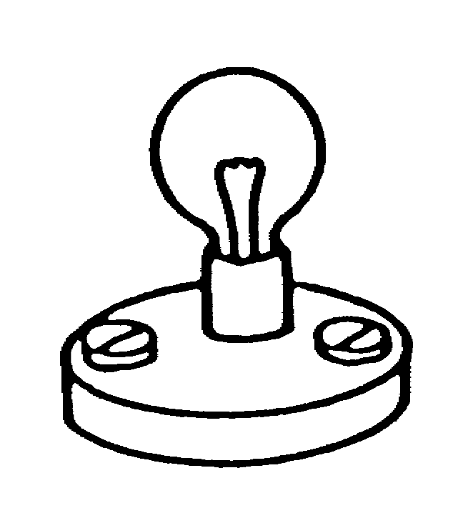
Battery

A bulb is connected to a battery.
The bulb is lit.

Which of the following best describes the electric current in this circuit?

Tick ONE box ()
Battery
❑ | There is an electric current through one wire to the bulb. It is all used up in the bulb. So there is no current in the other wire.
❑  Battery | There is an electric current through one wire to the bulb. Some of it is used up in the bulb. So there is a smaller current in the other wire.
❑  Battery | There is an electric current through one wire to the bulb. It passes through the bulb and back to the battery. The current in the other wire is the same size.
❑  Battery | There are two electric currents from the battery to the bulb. They meet at the bulb and this is what makes it light.

How confident are you that your answers to this question are correct? Tick ONE box ()

Very confident Fairly confident Not confident Just guessing

